**Data set**

**Medical Appointment –No Shows**

Context

A person makes a doctor appointment, receives all the instructions and no-show. Who to blame?

**URL**: <https://www.kaggle.com/joniarroba/noshowappointments/data>

**Content**:

300k medical appointments of the public healthcare of the capital city of Espirito Santo State - Vitoria - Brazil and its 15 variables (characteristics) of each. The most important one if the patient show-up or no-show the appointment

Attributes

|  |
| --- |
| PatientId |
| AppointmentID |
| Gender |
| ScheduledDay |
| AppointmentDay |
| Age |
| Neighbourhood |
| Scholarship |
| Hipertension |
| Diabetes |
| Alcoholism |
| Handcap |
| SMS_received |
| No-show |

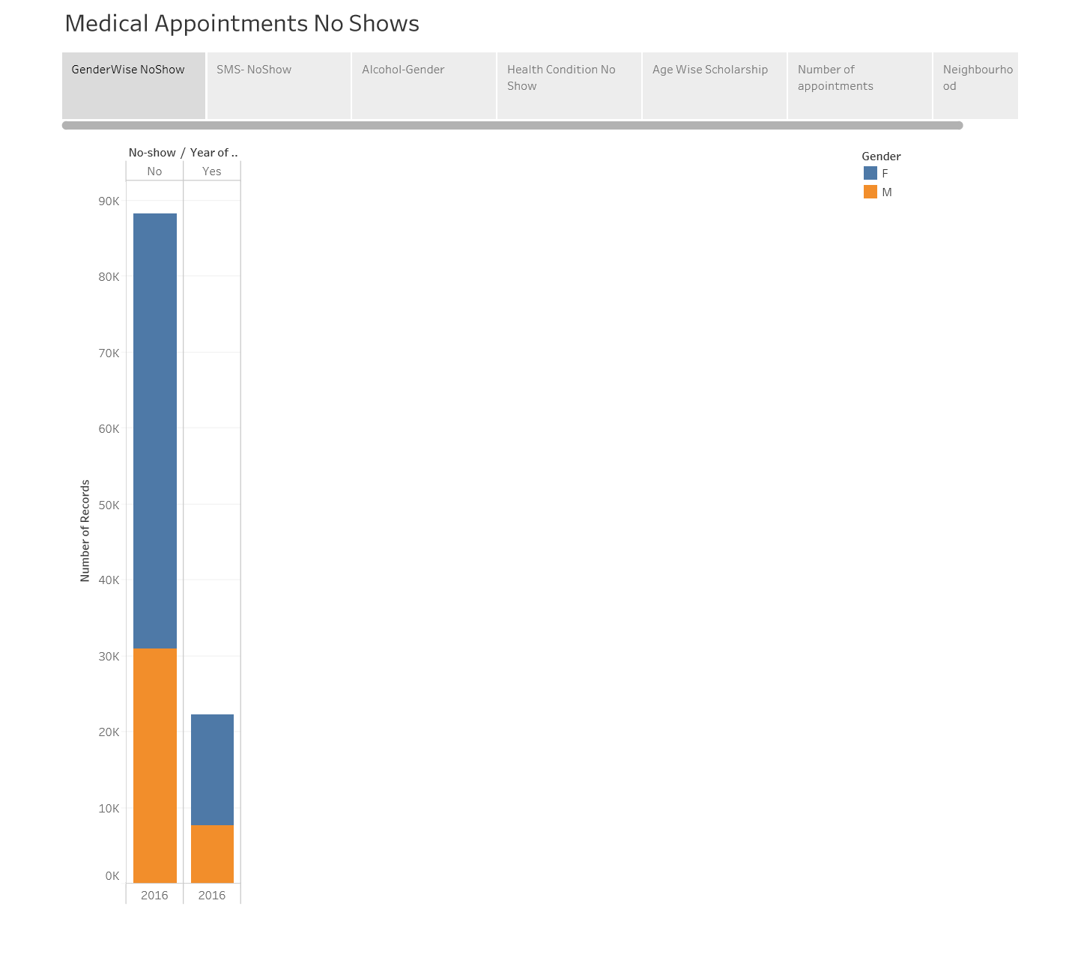

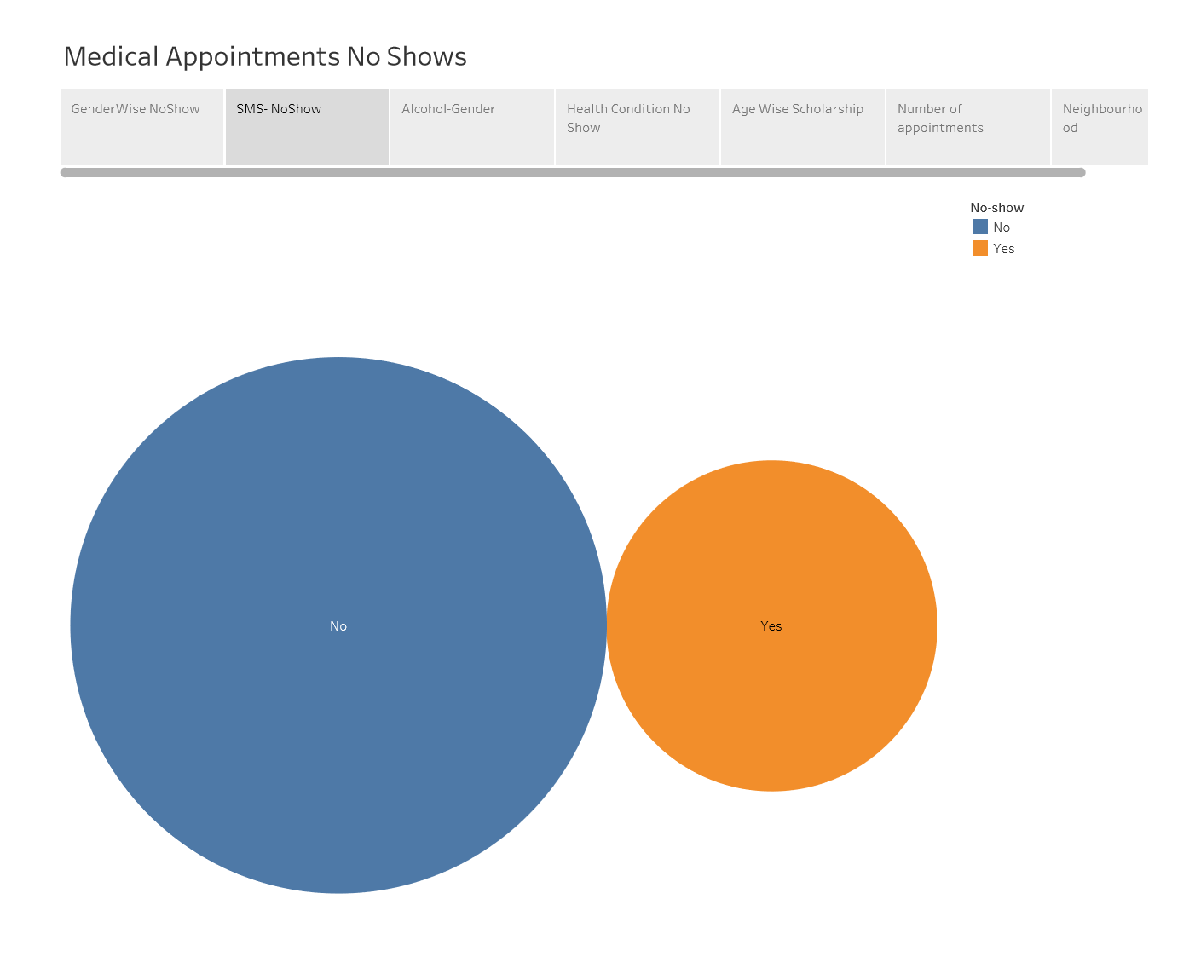w

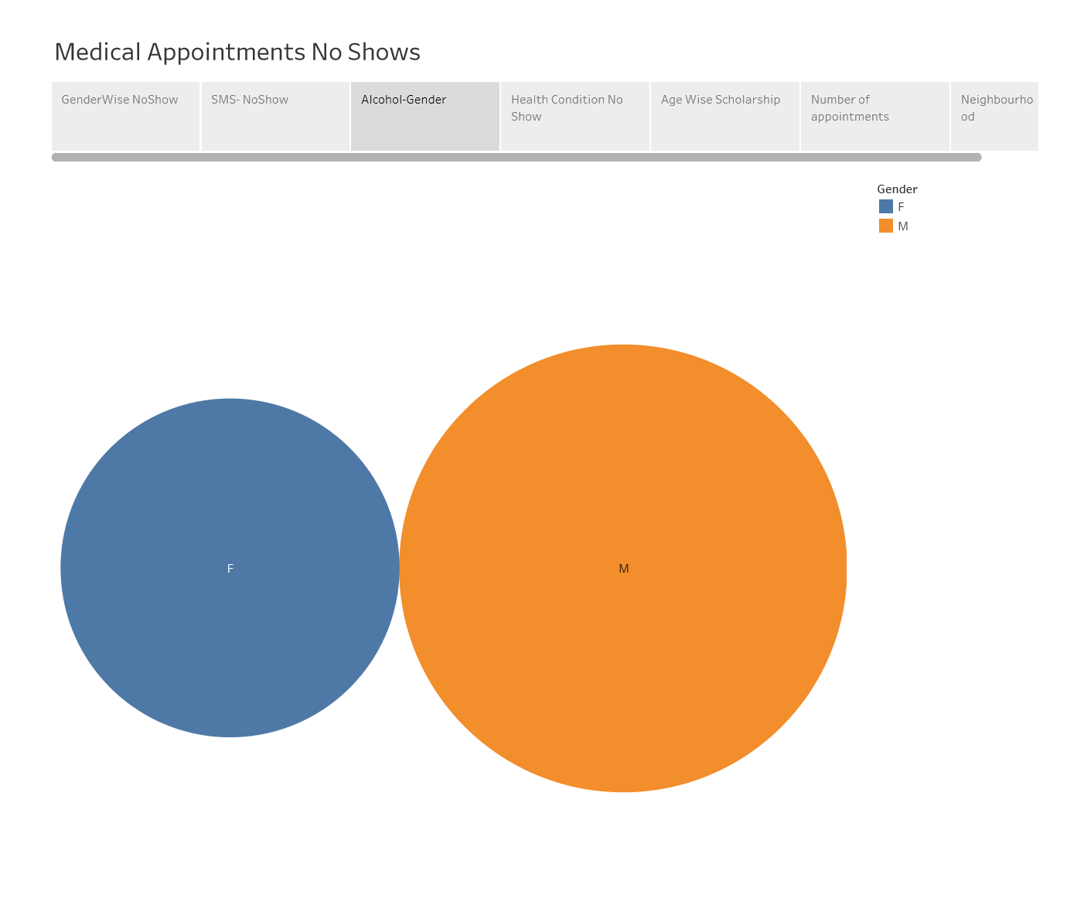

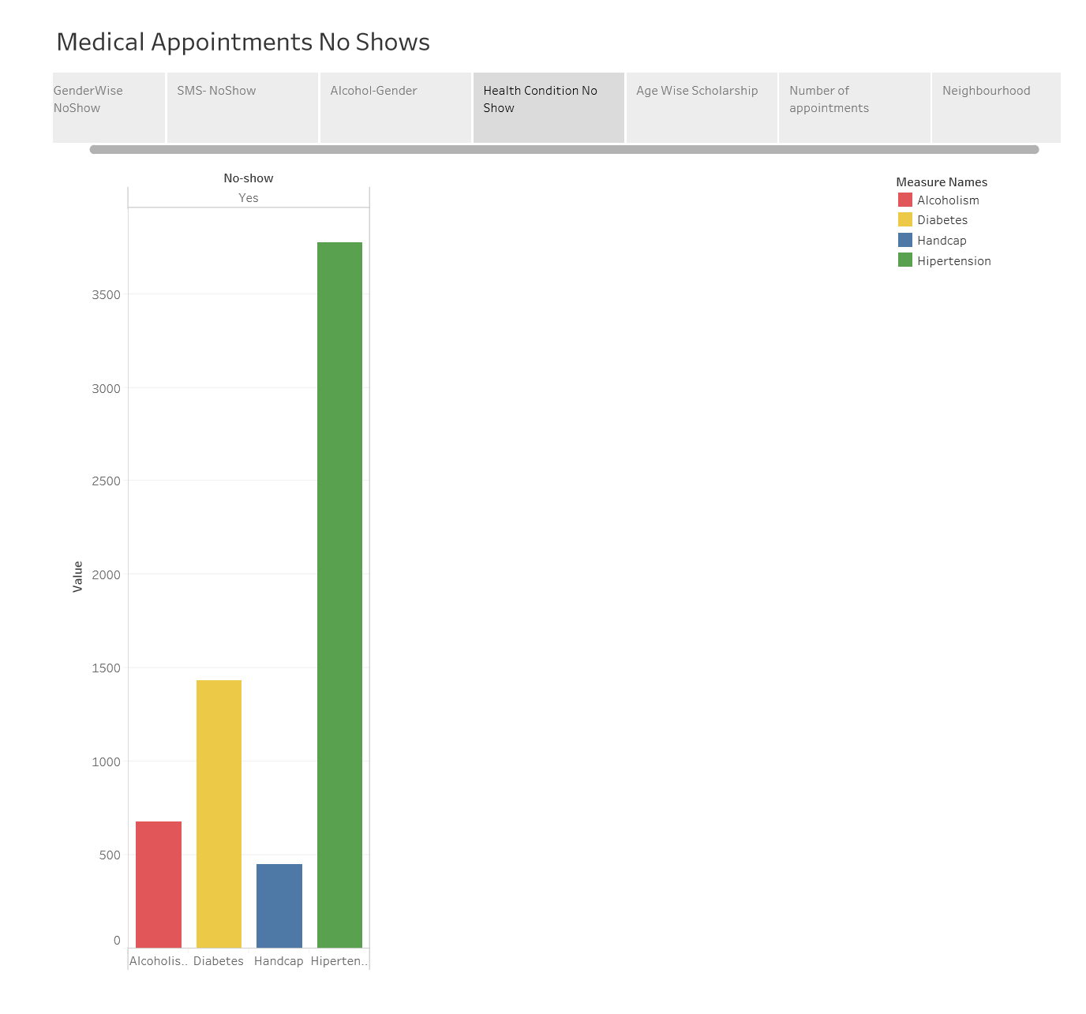

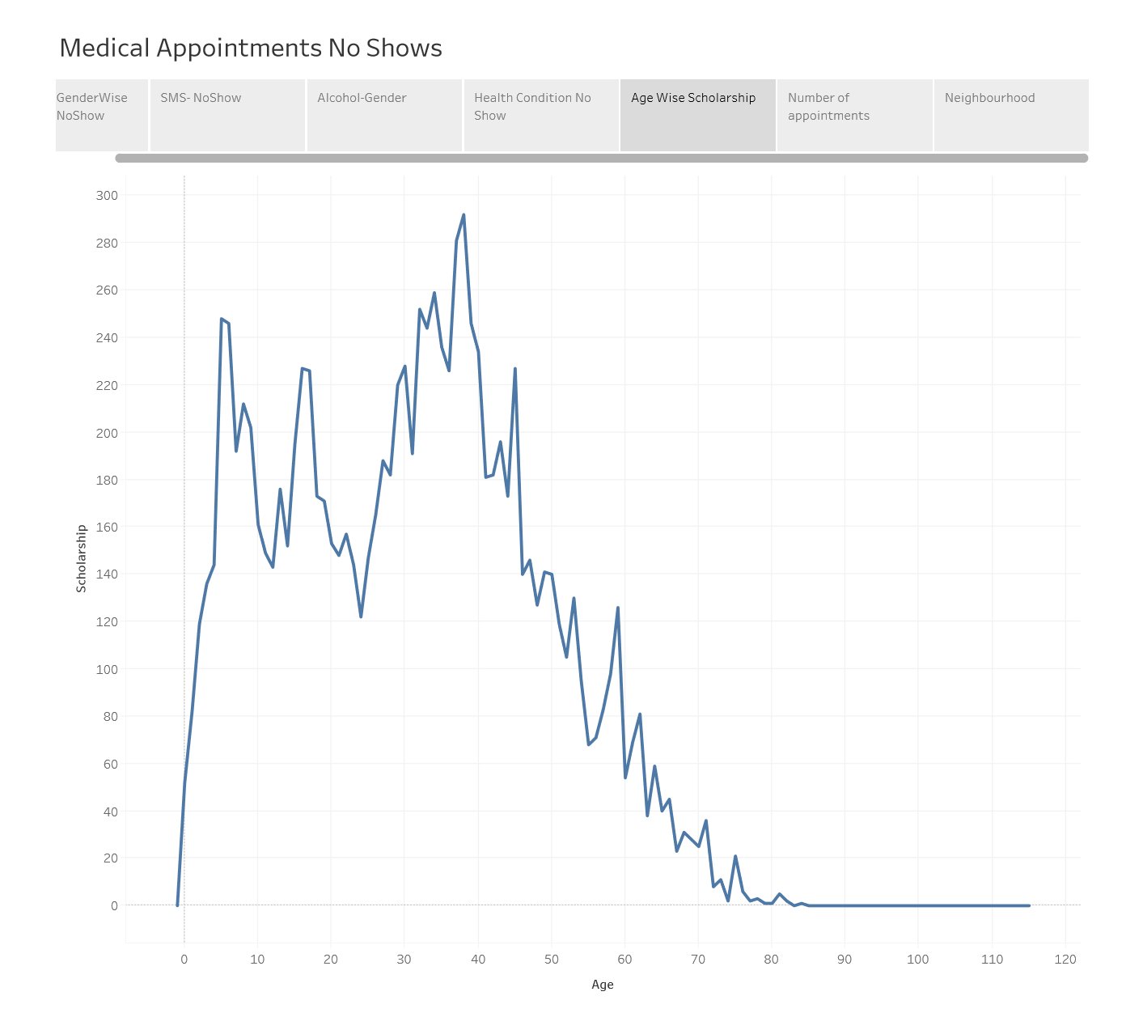

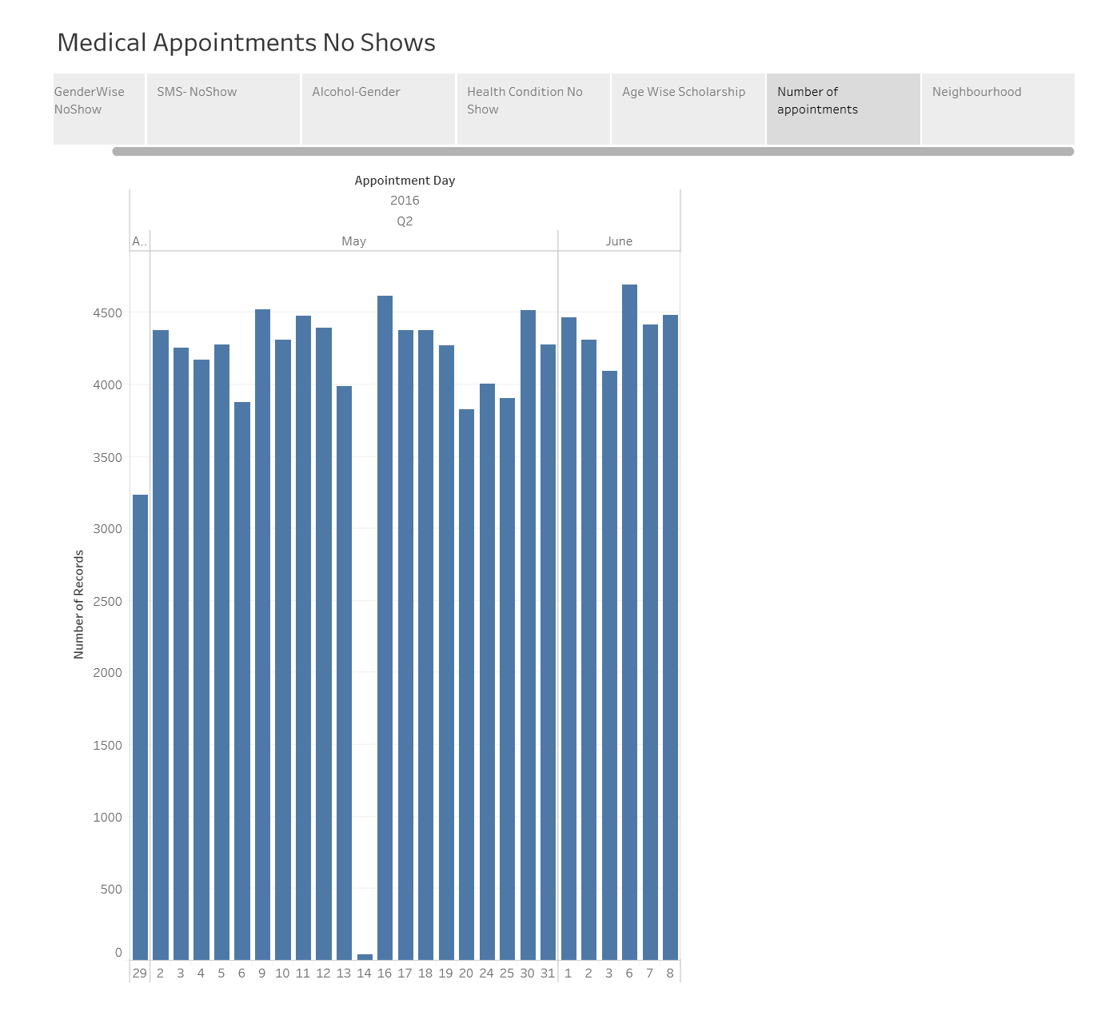

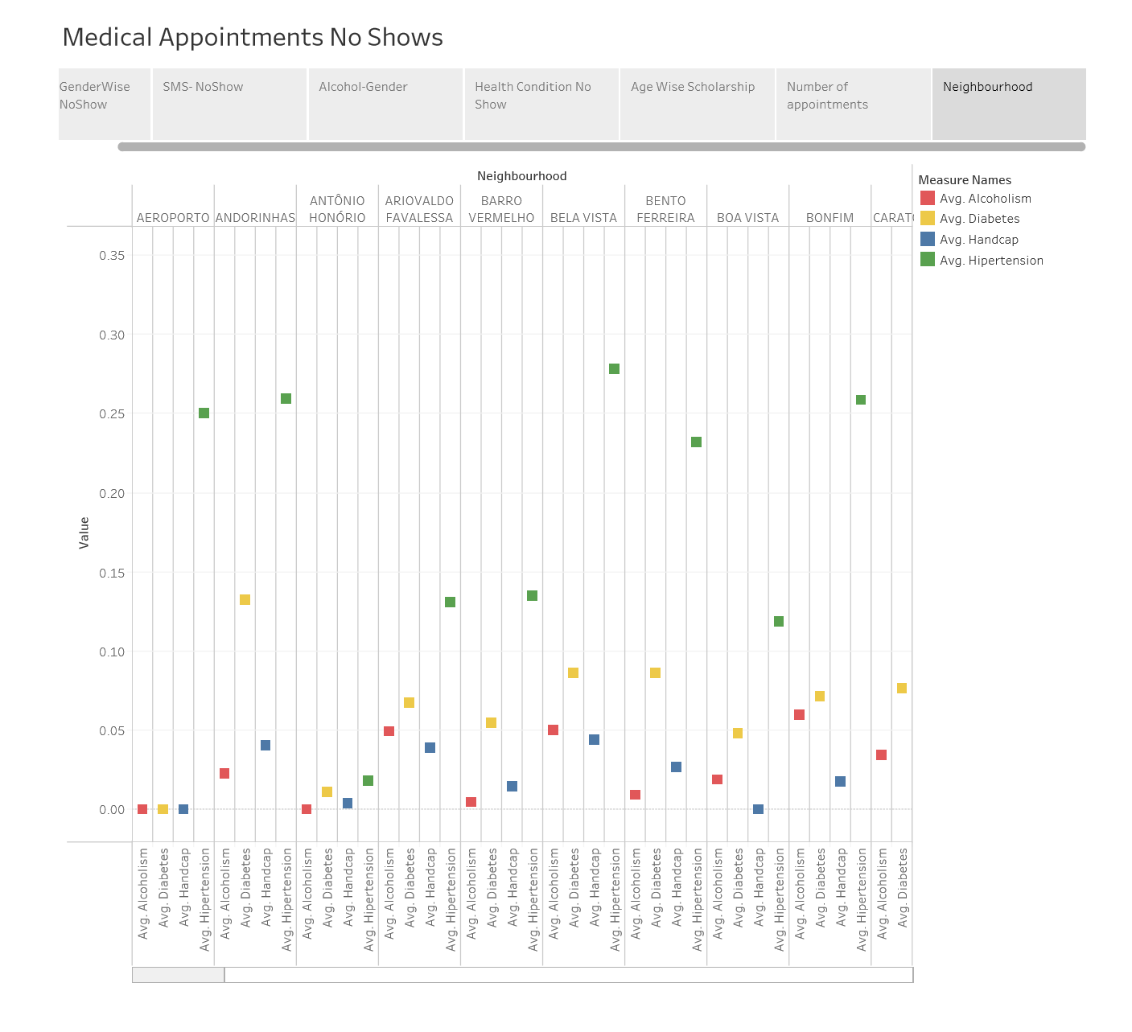s